Optimizing Machine Learning Algorithms on Quantum Dot-based Quantum Computers

**Ms.Pratibha sharma 1,Shreya Chauhan 2, Sarika Mehra 3, Kasak Girdhar 4**

**Assistant Professor 1,Student 2 ,Student 3 ,Student 4**

**Bhagwan Parshuram Institute of Technology, Rohini, New Delhi, India 1,2,3,4**

# ABSTRACT

Quantum mechanics has undergone significant advancements in the field of computer sciences. One of these advancements include quantum dot based quantum computers which own a special and unique ability to optimize the machine learning algorithms which again have proven to be greater achievement in this domain. This sector has validated to be of great interest to the researchers. This paper gives overview about quantum dot based quantum computers that have potential of accelerating the computation process in high dimensional space which classical computers cannot handle. This paper then dives deep into the developments that apply quantum dots in optimization of machine learning algorithms. It later provides the mathematical frameworks that combines quantum parallelism with machine learning to enhance computation processes. It then discusses the application of quantum dot based machine learning on image recognition. It also states some of the proposed models to strengthen this field. In this research, an exploration of how and why quantum dots can be used to perform machine learning algorithms in an optimized direction. Quantum dots have properties of tuning, information processing which can be controlled by applying static external magnetic field. Quantum dots have discrete qubit states which possess unique ability of superposition and entanglement which makes them stand ahead of the ordinary classical bits. Along with it, it also highlights some of the challenges that are faced by this newly emerging field of machine learning.

# INTRODUCTION

Machine learning is a vital section of computer science that works on helping machines to understand new data by finding patterns. This field has grown rapidly but it’s a tough optimization problem which reaches up to higher complexity level that requires highly proficient computers to handle it that cannot be handled by classical computers.Quantum dots are tiny semiconductor particles that confine electrons in all dimensions, leading to discrete energy levels. Their key properties for quantum computing include their ability to represent qubits through electron spin, maintain quantum coherence, and be finely tuned for specific behaviors. These traits make them promising for scalable quantum computing systems.

Quantum computing owns the feature to do many calculations at once and thus, sorting this problem but it is not as simple as it sounds. Quantum dots are tiny particles of semiconductor material which tend to lead a shift towards quantum dot-based quantum computers (QDQCs). These computers can improve on how we optimize machine learning algorithms. Amidst the increasing call for AI and big data, QDQCs can revolutionize the whole domain. This paper deals with how QDQCs can mark a turning point in the field of machine learning and advanced technology.

# MACHINE LEARNING

Machine learning (ML) is a subset of the wider field of Artificial Intelligence (AI). It works highly on the grounds of statistics. It builds a generalized mathematical model and

develops certain algorithms that process information to perform various tasks such as pattern identification or speech recognition and so on. In machine learning, a hypothesis function is used to frame a problem which is stated as below:

hθ (x) = θ0 + θ1x1 + …. + θnxn

Here, xi corresponds to a feature of a data, θ0 corresponds to the intercept term in the function, θi corresponds to the parameters of the model that define the influence of the feature on the final predictions.

For example: If the task is to predict house prices, the size of a house can be a feature for the given data (x) while θ0 representing base price of the house before considering any feature and θ1 representing the price increase for each additional unit of size of the house.

# MACHINE LEARNING TECHNIQUES

Machine Learning is majorly classified into Supervised Learning, Unsupervised Learning, Semi-supervised Learning, and Reinforcement Learning as shown in Fig 1. They are defined in brief as follows:

**Fig 1.** Classification of Machine Learning Techniques

**Supervised Learning:** In this, models are based on learning from labeled data i.e. it maps inputs to outputs based on examples with known outcomes. It can be used in prediction of class labels, text classification, etc.

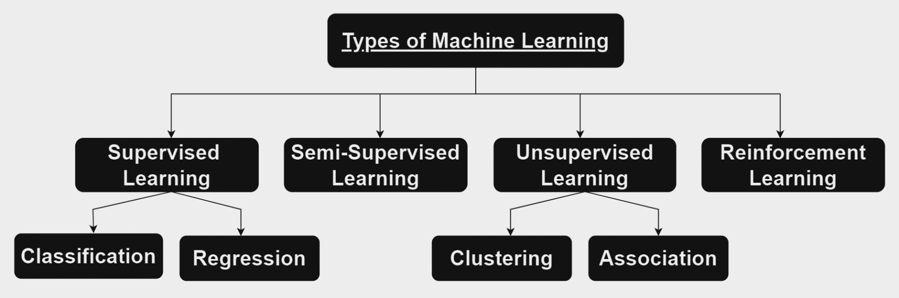

**Unsupervised Learning:** In this, models are based on learning from data by discovering undefined hidden patterns, trends or structures. Some unsupervised learning driven tasks include anomaly detection, density estimation, etc.

**Semi-supervised Learning:** In this, models are built using both labeled and unlabeled data with a major pool of unlabeled data. It provides more reliable predictions in comparison to task driven labeled data. Its applications are involved in machine translation, fraud detection and so on.

**Reinforcement Learning:** The model works upon environment-driven approach based on rewards or penalty making sequences of decisions and enhance its decision- making power by training itself to achieve rewards for the better decisions. It is utilized in automation or optimization of robotics systems, autonomous driving tasks and many more.

Thus, different machine learning techniques can be used depending upon the type of input data and the applications according to their learning capabilities.

# OPTIMIZATION PROBLEMS IN MACHINE LEARNING

Traditional machine learning algorithms face numerous challenges revolving around optimization. Basing the operational ability of the machine, number of tasks performed by classical machine learning algorithms are limited. Classical machine learning can offer higher dimensionality but it fails due to the weaker operational power of the system. With the increase in the input space and hidden multilayered feature maps of the data and the use of multi-layered complex neural networks modeled to perform certain recognition tasks, computational complexity increases which becomes difficult to execute. To improve these, GPUs (Graphics Processing Units) are installed for accelerating the process of computation but it offers only some limited paced computations and hence, the problem still persists which can

be best solved by the Quantum Dots based Quantum Computers using the method of quantum parallelism.

**Fig 2.** Multi-layered Neural Network

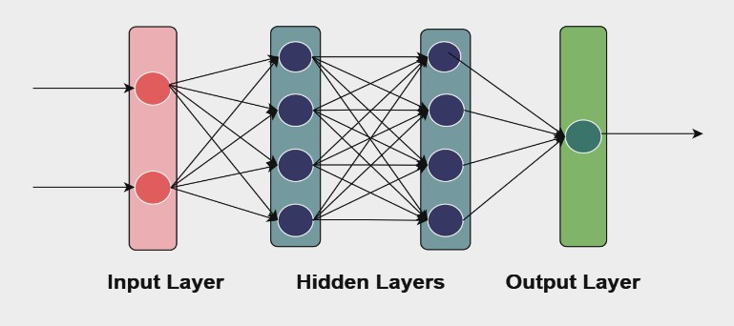

# ROLE OF QUANTUM DOTS IN COMPUTATION

Quantum dots form the basis of the quantum computing. Quantum dots are zero-dimensional semiconductor nanoparticles. When subjected to a magnetic field (required to control the orientation and spins of qubits) , the energy levels in a quantum dot split into multiple sublevels causing Zeeman’s Splitting. It varies from one quantum dot to another which helps in selective manipulation of the spins among different quantum dots and therefore, help in information processing. It depends upon the material of the semiconductor used. Germanium Arsenide is the most extensively used semiconductor material that is used to create quantum dots for its low disorder ability. Silicon also follows the utilization for its ability to exhibit excellent qubit properties and low coherence that helps in stable quantum operations.

Quantum dots promise to provide various advantages for machine learning and computations:

* **Tunable Properties:** The property of tunability in quantum dots assists in managing the optical properties with specific energy levels by changing their composition or shape. Changing the voltages of quantum gates alters the position of quantum dots and makes them tunable electrically via Zeeman splitting.
* **Isolation:** QDs are isolated from the surroundings that in turn maintains essential conditions required to maintain coherence over longer periods easing the quantum computations. However, coherence requires lower temperature and research is still going on over it.
* **Information Carriers:** QDs can encode information in spins, degrees of freedom with their ability of superposition and entanglement. The data can be transported by using swapping operation in the qubit states.
* **Spin-based Computations:** Electrons are half spin particles with two orthogonal spin states either spin up ( 1 )

2

flips the second qubit strictly only if the first bit is 1 which can be mapped as *a*|00⟩ + *b*|01⟩ + *c*|10⟩ + *d*|11⟩ → *a*|00⟩ + *b*|01⟩ + *c*|10⟩ + *d*|10⟩. In its matrix form, it can be represented as:

CNOT =

|  |  |  |  |
| --- | --- | --- | --- |
| 1 | 0 | 0 | 0 |
| 0 | 1 | 0 | 0 |
| 0 | 0 | 0 | 1 |
| 0 | 0 | 1 | 0 |

Hadamard gate is given as:

or down (−1 ). The information is stored in these spins. They

2

exist inside discrete and quantized energy levels of QDs

H: |0

⟩ → |+⟩ =

1 (|0⟩ + |1⟩)

√2

which are referred to as qubits. Qubit is defined as the fundamental unit of quantum computation. Qubits in QDs possess the composite state, i.e., the electrons can exist in two distinct states at a time ‘0’ and ‘1’ states. This makes them capable of superposition and entanglement that helps speedup execution of operations. In 2-D Hilbert space, qubits are represented by unit vector |*α*⟩. Qubit can be vectorially represented as |*ψ*⟩ = *α*|*0*⟩ + *β*|*1*⟩ where *α, β* ∈

|1⟩ → |-⟩ =  1 (|0⟩ - |1⟩)

√2

Hadamard transformation is applied to the tensor product of the three states that fastens the computation process that

ultimately gives us  1 (|000⟩ + |100⟩).

√2

Hadamard gate to each qubit in an (n)-qubit under superposition of all possible states:

𝐻⊗𝑛|0⟩⊗𝑛 = 1 ∑2𝑛−1 𝛼 |𝑥⟩ ;

ℂ. The Bloch sphere (Fig 3) represents a single qubit state as

√2𝑛

𝑥=0 𝑥

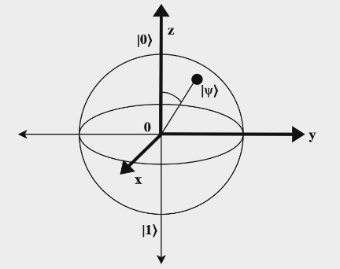a point on the surface of the sphere.

𝛼𝑥 is a complex coefficient, |𝑥⟩ is the basis state

For CNOT gate, if the latter tensor has 0 with 1 in the former tensor, it is swapped to 1 that gives us  1 (|000⟩ +

√2

**Fig 3**. Bloch Sphere

The probability to find qubit in 0 or 1 state is measured by squaring their respective amplitudes (|*α*|2 and |*β*|2 respectively) and the sum of the probabilities is 1 (|*α*|2 +

|*β*|2 = 1). The basis state, phase or amplitude can be manipulated through these single qubit quantum gates. Quantum gates are represented as unitary matrices. All the quantum gates have different purposes as mentioned in the table:

|  |  |  |
| --- | --- | --- |
| **GATE** | **INPUT** | **DESCRIPTION** |
| **Hadamard (H)** | 1 qubit | Superposition |
| **CNOT** | 2 qubit | Controlled NOT gate |
| **Taffoli** | 3 qubit | 3 qubit operation |
| **SWAP** | 2 qubit | Bit swapping |
| **AND** | 2 qubit | AND operation |
| **X (Pauli gate)** | 1 qubit | X-rotation |
| **Y (Pauli gate)** | 1 qubit | Y-rotation |
| **Z (Pauli gate)** | 1 qubit | Z-rotation |

Two qubits are represented as |*α β*⟩ = |*α*⟩ ⊗ |*β*⟩ = *α*00|00⟩ +

*α*01|01⟩ + *α*10|10⟩ + *α*11|11⟩ in vector form. The CNOT gate

|111⟩) as the final transformation.

# QUANTUM PARALLELISM

Quantum parallelism refers to the idea of finding multiple solutions in parallel at the same time along with computing tensor product. Quantum parallelism is often misunderstood to calculate different paths simultaneously but in reality, it applies to superposition of quantum states. Superposition simply refers to the existence of quantum dots in multiple states simultaneously through entanglement. Entanglement theory describes the relation among the states under superposition. Qubits exist in intermediate states following entanglement even over light years of distance which remains entangled even after the physical separation from each other.

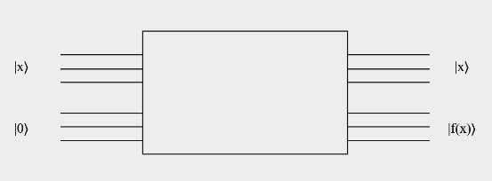

Consider a quantum gate array *Uf* applied to an arbitrary function in superposition with *p* input bits and *q* output bits. A superimposed result is obtained as follows:

Uf |x, y⟩ → |x, y ⊕ f(x)⟩

⅀ ax |x, 0⟩ → ⅀ ax |x, f(x)⟩

Here, x and y can form any combination of 0 and 1.

Thus, *f(x)* can be computed for many values of x at once only but all the output values cannot be obtained directly simultaneously due to the probabilistic nature of quantum measurement. But the quantities associated to various outputs of *f(x)* can be extracted. This explains the concept of quantum parallelism broadly.

Theoretically, it can be clearly understood by an instance of tossing a coin. The coin spinning in the air represents both head and the tail side of the coin at the same time. The application of *Uf* on the spinning coin considers both the sides of the coin simultaneously and the superimposed result process all the possibilities of the outcomes (getting a head or a tail) in one moment but the coin lands only on one side since all the outcomes cannot be observed at once and same works for analyzing the quantum state.

In this manner, quantum parallelism can be used to compute

It transforms quantum state |0⟩ to (|0⟩ + |1⟩)/√2 and |1⟩ to (|0⟩ - |1⟩)/√2 where 0 and 1 correspond to black and

white image respectively. The binary sequences a1 · · · aP

−10 and a1 · · · aP −11, with ai ∈ {0, 1} depict the position of neighboring pixel data stored as coefficient c (s) a1···aP−10 and c (s) a1···aP−11 which gets transformed to c (s) a1···aP−10 ± c (s) a1···aP−11. This vector is embedded in higher dimensional space denoted by R2P to apply tensor product H ⊗ IP where Ip is defined as the identity matrix. For any quantum state that express an image, the final state is obtained by vector of differences between the coefficients of neighboring pixels wherein the difference is zero for the pixels belonging to the same region else non-zero that indicates an edge. Following it, an output state projecting onto the components with the differences of the coefficients can be expressed as:

c (s) – c (s)

many values for f(x) and to obtain information out of those 0 1

1 c (s) – c (s)

values of f(x), concept of interference i.e. Hadamard 1 2

c (s) – c (s)

transformation is used. Interference can provide us information in two ways:

√2 2

c

3

(s) – c (s)

**Positive Interference:** |0⟩ and |0⟩ add up to give a higher probability.

**Negative Interference:** |1⟩ and - |1⟩ add up to cancel each other.

Quantum computations stand ahead in terms of handling tensor and high dimensional dot products along with the quantum parallelization solving complex algorithms which cannot be handled by classical computers.

# IMAGE RECOGNITION QUANTUM DOTS BASED COMPUTATIONS

Here, an application of image recognition has been explained that makes the use of quantum dot based machine learning. Researchers began with a 3-D image given by F = (vijk) M × L

× N with each element representing a pixel value. It will use the encoding of higher dimensional data represented by f(s) =

(v (s) ,…,v (s))t for each s time; s ≤ s ≤ s , v represents the pixel values. The vector f(s) is mapped onto a quantum state given by an expression |f(s)⟩ = ⅀ck(s) |k⟩ where |k⟩ encodes position of pixel and ck(s) encodes pixel value and hence, this coefficient is normalized. After encoding, quantum transformations, may it be Hadamard, Fourier or other, are used. Quantum states are then manipulated using these linear operations to perform edge detection where the boundaries are identified within the image. Quantum computing accelerates this process by simultaneous processing of all pixels. It then causes superposition of states for efficient edge identification within the images.

1 p 0 T i

One such example algorithm can be formed using Hadamard Gate which is defined as:

p-1 0

This output state encodes the boundary information at some time ‘s’. Several parts of the algorithm could be solved at one moment with the help quantum parallelism in an optimized way.

# BENEFITS OF IMAGE RECOGNITION

# 1.Speedup via Parallelism: Quantum dots allow image recognition models to process multiple possibilities simultaneously due to quantum parallelism, which significantly speeds up tasks like feature extraction, classification, and pattern matching.

# 2.Efficient Handling of Complex Data: Classical image recognition often struggles with processing complex, high-dimensional data (e.g., medical images or satellite imagery). Quantum dot-based systems can handle such complexity more efficiently by leveraging the power of qubits.

# 3.Enhanced Accuracy: Quantum superposition and entanglement allow quantum dots to explore multiple solutions at once, leading to more accurate image recognition results by considering all possible configurations simultaneously.

# 4.Reduced Computational Resources: Quantum systems can potentially reduce the need for extensive hardware and energy, which are required in classical machine learning to train deep networks, especially for high-dimensional image data.

# PROPOSALS AND TOOLS FOR QUANTUM DOTS BASED QUANTUM COMPUTATIONS

* **Loss and Divincenzo Proposal:** It works on electron spin based quantum computations in QD systems.
* **Golovach and Loss Proposal:** It uses the implementation of 2-DEG using QDs by electrical gating of semiconductor well.
* **Biexcitonic Rabi Oscillations:** Doubly excited states with the presence of two holes and electrons simultaneously form biexcitons which couples to other states under an oscillating electromagnetic field that is useful in efficient implementation of quantum gates, controlled quantum rotations and qubits entanglement.
* **Time-Varying Zeeman Coupling:** It can control single spin rotations which play a fundamental role in quantum computing.
* **Spontaneous Magnetization and Tunneling:** They can extract information from the quantum state of a spin.

# EXPERIMENTAL ADVANCES

* **Material Engineering:** It requires the use of materials with varying g-factors (factor that characterizes the magnetic moment and angular momentum of a particle and determines the interaction of spin of electron or hole with

H = 1

√2

1 1

-1 -1

magnetic field) for Quantum Dots as it facilitates Zeeman Splitting and thus, help in stable quantum operations.

* + **Controlled-Rotation Gate (CROT):** It provides a reliable assistance for easy rotation between the quantum states .

# CHALLENGES AND FUTURE DIRECTIONS

The quantum dots based machine learning faces a lot of challenges in its way which include scaling up of quantum dot based quantum computers, prevention of decoherence, and many more. Under the future scope of this research, the points of research will include overcoming these challenges and discovering new methodologies that can be adopted to use quantum dots proficiently to optimize the machine learning process. The ultimate success of this optimization depends upon utilization of the quantum dots in a manner that provides the most reliable and accurate solutions along with the least computation complexity and the remarkable efficiency.

# CONCLUSION

In this research, an exploration of how and why quantum dots can be used to perform machine learning algorithms in an optimized direction. Quantum dots have properties of tuning, information processing which can be controlled by applying static external magnetic field. Quantum dots have discrete qubit states which possess unique ability of superposition and entanglement which makes them stand ahead of the ordinary classical bits. Using various quantum gates operations, these states can be read out and with the application of mathematical expressions, output for all the input data can be encoded simultaneously but cannot be observed all at once. Quantum parallelism has proved to be a great step in this direction of research and more such researches could be found leading its way ahead in the same direction in the future.

# LIMITATIONS

# 1.Quantum Coherence: Quantum dots lose coherence

# quickly, leading to errors during computation.

# 2.Error Correction: Implementing quantum error

# correction is complex and challenging.

# 3.Scalability: Difficult to scale quantum dot systems

# to handle large numbers of qubits.

# 4.Qubit Control: Precise control over quantum dots

# for qubit manipulation is technically challenging.

# 5.Limited Quantum Speedup: Quantum speedup is

# not applicable to all machine learning tasks; classical

# algorithms still outperform in many areas.

# 6.Data Encoding: Converting classical data to quantum

# states is inefficient and complex.

# 7.Noise Sensitivity: Quantum dots are sensitive to

# environmental noise, affecting computation accuracy.

# 8.Quantum Gates: Quantum operations are error-prone,

# limiting the benefits of quantum parallelism.

# REFERENCES

1. Schuld, Maria, Ilya Sinayskiy, and Francesco Petruccione. "An introduction to quantum machine learning." Contemporary Physics, vol. 56, no. 2, 2014, pp. 172–185.
2. Dasari, Venkat R., Mee Seong Im, and Lubjana Beshaj. "Solving machine learning optimization problems using quantum computers." 2019. arXiv:1911.08587 [quant-ph].
3. Baek, Joon Ho, et al. "Quantum Computing with Quantum Dots." Computing Beyond Silicon Summer School, 2004, pp. 44-65.
4. Sarker IH. Machine Learning: Algorithms, Real-World Applications and Research Directions. SN Comput Sci. 2021;2(3):160. doi: 10.1007/s42979-021-00592-x. Epub

2021 Mar 22. PMID: 33778771; PMCID: PMC7983091.

1. Nivelkar, Mukta, and SG Bhirud. "Modeling of Supervised Machine Learning using Mechanism of Quantum Computing." Journal of Physics: Conference Series, vol. 2161, no. 1, 2022, p. 012023.